# **Testing**

Testing is the process of running or executing the program or application to find the software bugs that can be fixed. It is also the process of validating or verifying that the application or program that is being developed meets the business and technical requirement that is stated, it is also the method to know if it works as expected.

Software testing is important so that it could detect the bugs in the software and also test it the software meets the customers’ requirements.

## **Types of testing:**

There are different types of testing that are suitable for different programs and application so I have chosen Black Box testing and White Box testing (Unit testing).

1. **Black Box Testing:**

* The Black box testing Is the software testing which is used to test the software without knowing the internal structure of code or any program. The main purpose of the black box testing is to check whether the software is working as per expected in requirement document and it is meeting the user expectation or not.

**Testing for registration**

|  |  |
| --- | --- |
| Test Case | R01 |
| Purpose of test | Successfully Register New User |
| Test Data | Fname:Upendra  Uname:upendra007  Phone:09534532432  Email:upendra123@gmail.com  Password:1234  Confirm Password:1234 |
| Expected Result | Registration successful |
| Actual Result | Invalid Phone |
| Conclusion | Phone Number were more than 10 digits. |

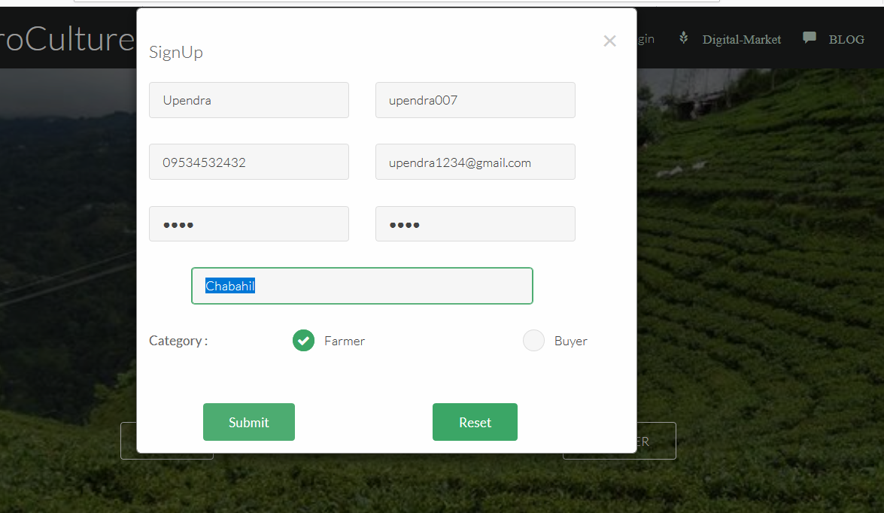

Figure : Invalid field

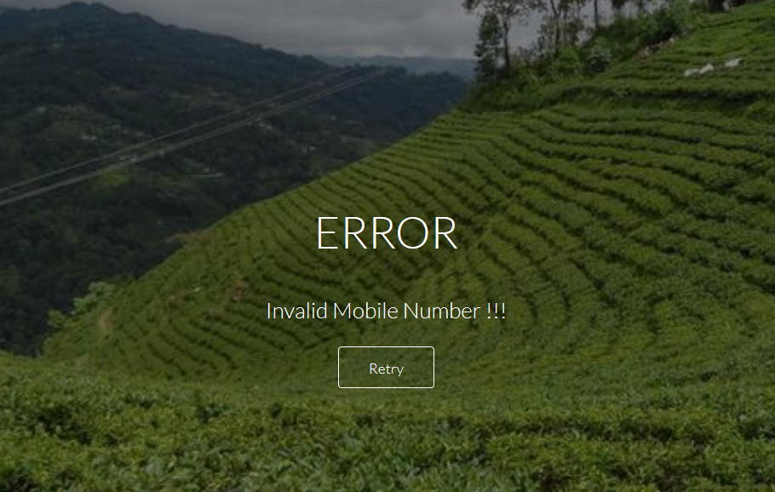

Figure : error message

|  |  |
| --- | --- |
| Test Case | R02 |
| Purpose of test | Successfully Register New User |
| Test Data | Fname:Upendra  Uname:upendra007  Phone:9876543210  Email:upendra1234@gmail.com  Password:1234  Confirm Password:1234 |
| Expected Result | Registration successful |
| Actual Result | Registration successful |
| Conclusion | Phone Number was corrected |

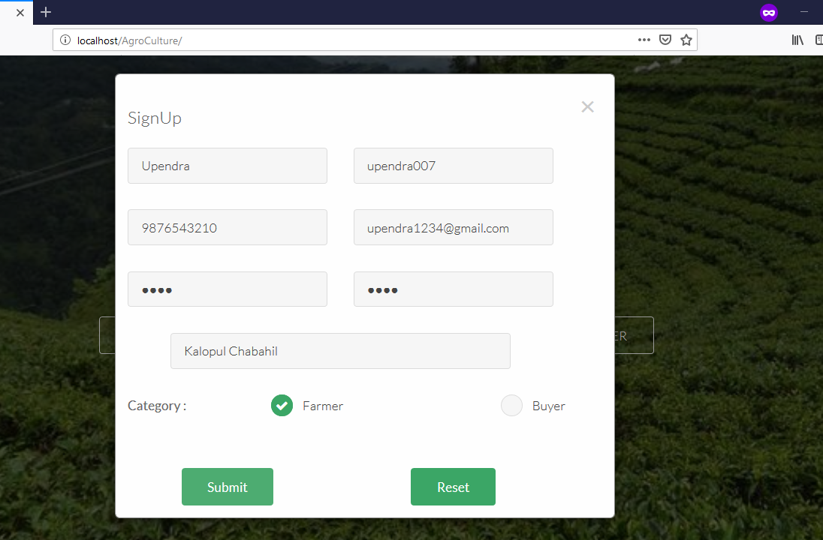Figure : Registration of new user

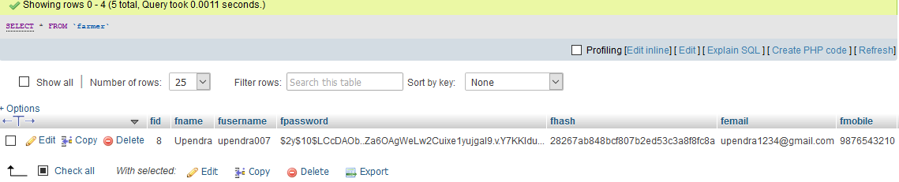

Figure : Successful insert of user detail

***Testing for login***

|  |  |
| --- | --- |
| Test Case | R03 |
| Purpose of test | Successfully Login |
| Test Data | Uname:upendra007  Password:1236 |
| Expected Result | Login successful |
| Actual Result | Invalid User Credentials |
| Conclusion | Password was incorrect |

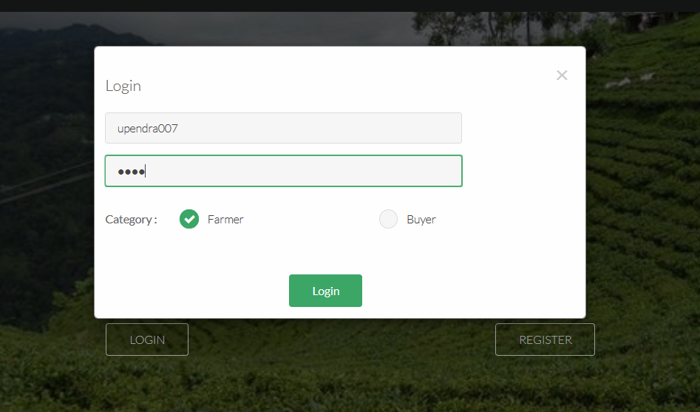

Figure : Login to user

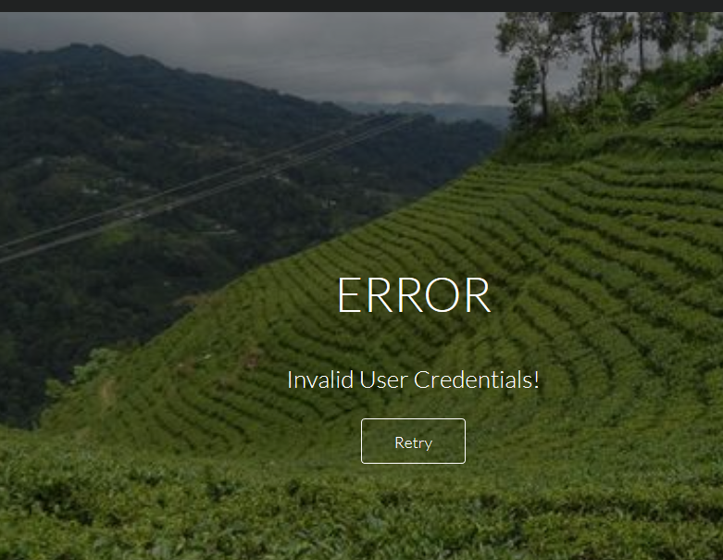

|  |  |
| --- | --- |
| Test Case | R04 |
| Purpose of test | Successfully Login |
| Test Data | Uname:upendra007  Password:1234 |
| Expected Result | Login successful |
| Actual Result | Login successful |
| Conclusion | Password was corrected |



Figure :Login



Figure : Successful login

***Testing for Home Page***

|  |  |
| --- | --- |
| Test Case | R05 |
| Purpose of test | Home |
| Test Data | Home button was clicked |
| Expected Result | Move to home page |
| Actual Result | Move to home page |
| Conclusion | Redirected to home page |

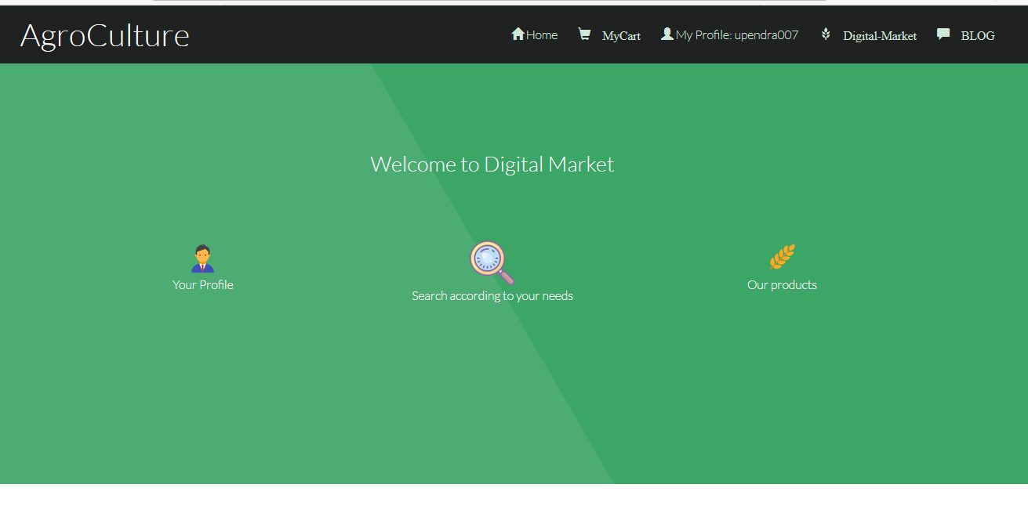Figure : Home Page

***Testing for Upload new product***

|  |  |
| --- | --- |
| Test Case | R06 |
| Purpose of test | Upload |
| Test Data | All field were filled and image was uploaded |
| Expected Result | Update Successfully |
| Actual Result | Update Successfully |
| Conclusion | Update Successfully |

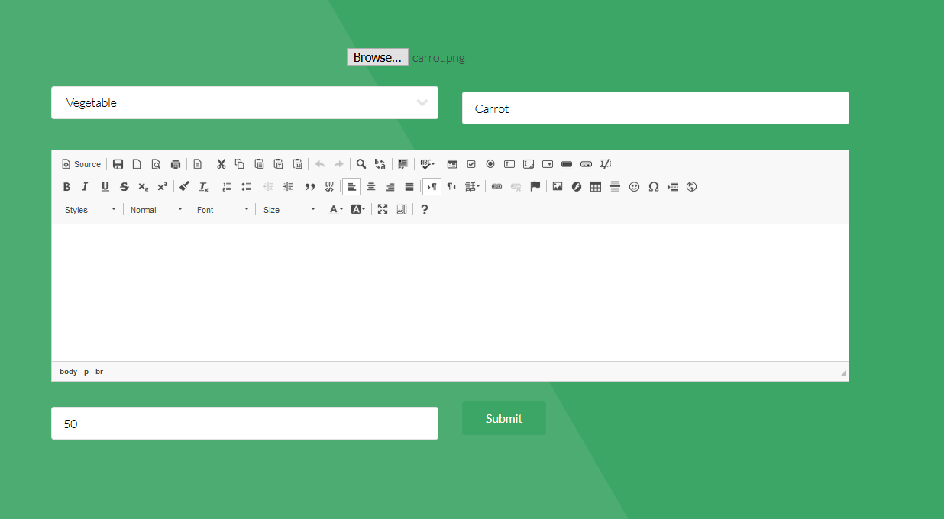

Figure : New Product Upload

***Testing for Upload new product***

|  |  |
| --- | --- |
| Test Case | R07 |
| Purpose of test | Buy product |
| Test Data | Add to cart was clicked |
| Expected Result | Add to cart successful |
| Actual Result | Add to cart successful |
| Conclusion | A product was added to cart |

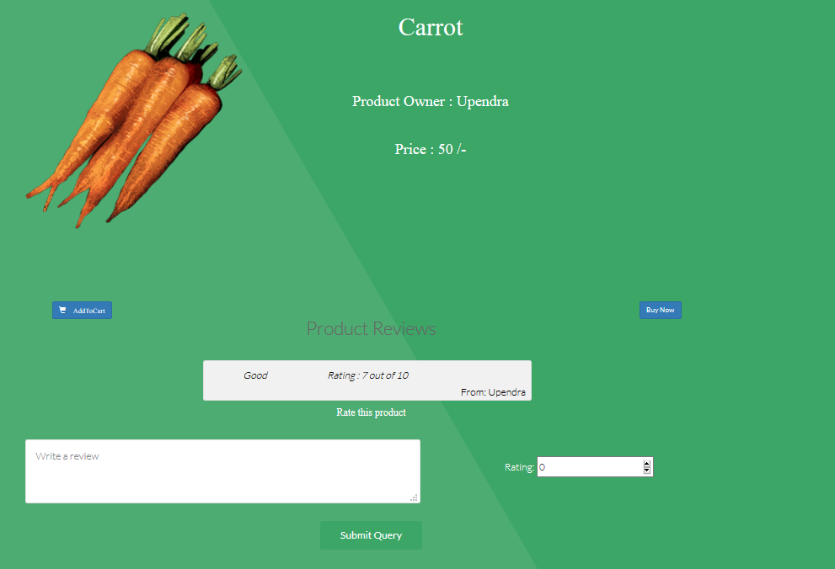

Figure : Buy a product

***Testing for Transaction***

|  |  |
| --- | --- |
| Test Case | R08 |
| Purpose of test | Transection |
| Test Data | Name, Address, Phone, Postal Code was inserted. |
| Expected Result | Order was successful |
| Actual Result | Order was successful |
| Conclusion | Success |

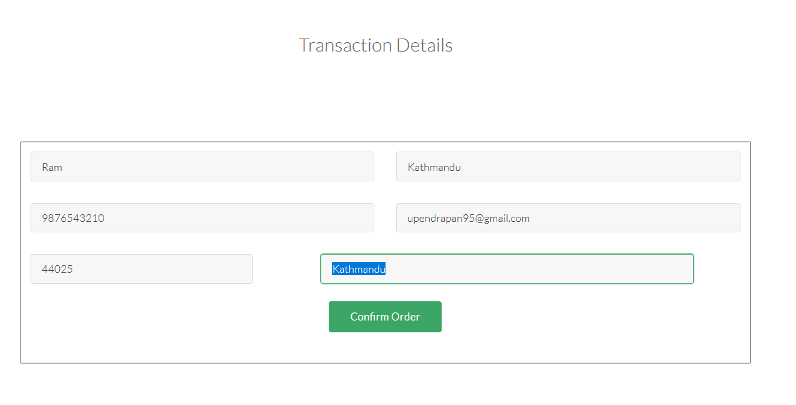

Figure : Transaction of product



Figure : Order Successful

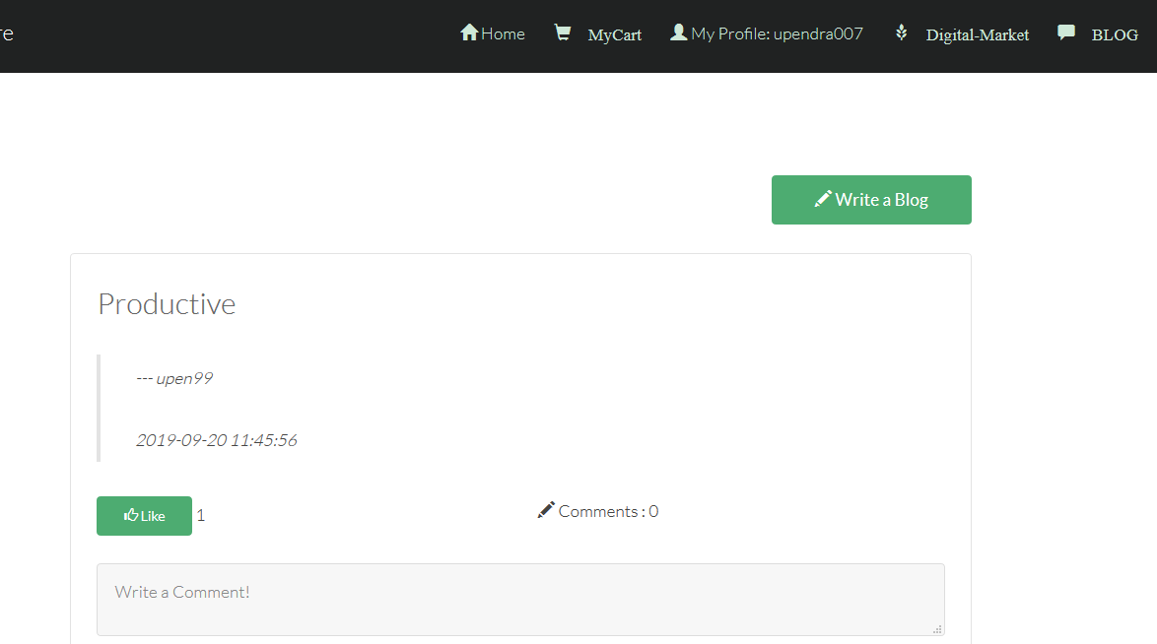

Figure : Write a new blog

1. **White Box Testing (Unit Testing):**

* White box testing is the testing in which the internal code of program is examined to find the bugs and error present in the application or program. Unit testing is the smallest testable part of an application like functions, classes or interface. It is the method by which individual units of source code are tested to determine if they are ready to use.

